**SETTING UP APPLICATION ENVIRONMENT**

|  |  |
| --- | --- |
| DATE | 16 NOV 2022 |
| TEAM ID | PNT2022TMID47104 |
| PROJECT NAME | Project – Inventory Management System for Retailers |

FLASK PROJECT:

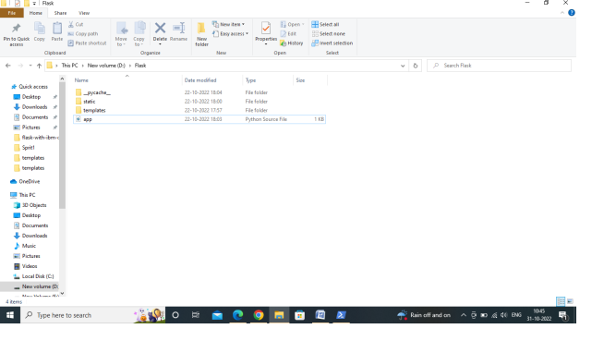

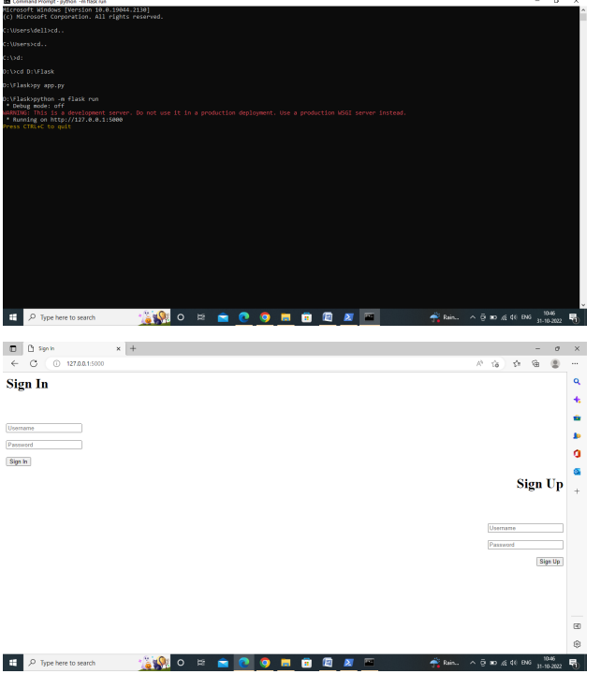

DOCKER SETUP:

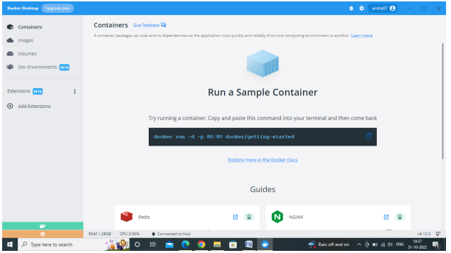

CREATE AN ACCOUNT IN IBM CLOUD:

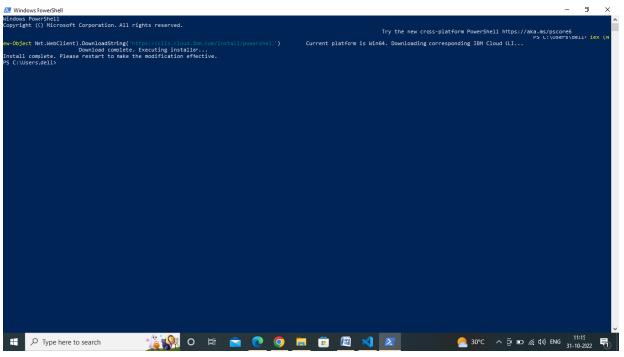

CREATE AN ACCOUNT IN SENDGRID:

